Online Food Ordering Website Report

Cover Page

Student Details
- Student Name: Ronald Muli
- Admission Number: BSCCS/2024/73536
- Unit Code: BIT3208
- Unit Name: Advanced Web Design and Development
- Lecturer Name: Nyoro

Project Details
- Project Title: Online Food Ordering Website
- Selected Technologies:
  - HTML
  - CSS
  - JavaScript
  - PHP
  - MySQL
  - XAMPP

GitHub / Portfolio Link
- GitHub Repository: https://github.com/ronniemuli274-hub/online-food-ordering-website

Table of Contents
Table of Contents
Online Food Ordering Website Report 1
Cover Page 1
Student Details 1
Project Details 1
GitHub / Portfolio Link 1
Table of Contents 1
Week 1: Local Environment Setup 3
Title 3
Installation of XAMPP Successful installation of XAMPP software used to run Apache and MySQL services locally. 3
Apache and MySQL Running 4
This screenshot shows Apache and MySQL services running successfully from the XAMPP control panel. 4
Localhost Test Page demonstrating successful access to localhost using a browser. This verified that the local server was functioning correctly. 4
Database Connection Test connection between PHP and MySQL using mysqli_connect(). It confirmed that the database credentials and server settings were correct. 4
Reflection 5
Week 2: Wireframes and GUI Design 5
Title 5
Fig 1: Homepage Wireframe This screenshot shows the planned structure of the homepage including navigation menus, food categories, and order sections. The design was planned to make navigation easy for users. 5
Fig 2: Dashboard Layout The dashboard layout was designed to organize food items, customer orders, and management sections clearly. 6
Fig 3:Color Theme and Navigation Structure The selected color theme improves visibility and user experience. Navigation links were positioned clearly to help users move between pages efficiently. 7
Fig 4: GUI Prototype Design This screenshot shows the prototype created using design tools before actual coding started. It helped visualize the final appearance and workflow of the website. 7
Student Reflection 7
Week 3: JavaScript and PHP Basics 7
Title 7
Fig 1: JavaScript Form Validation This screenshot shows JavaScript validation preventing users from submitting empty forms. Validation improves user interaction and reduces invalid submissions. 7
Fig 2: Password Hashing The password hashing was designed to enhance database password security It hashes passwords ,thus they appear as a combination of characters in the database 8
Fig 3: javascript Syntax Practice This screenshot demonstrates javascript scripting used to process website functionality. Javascript was used to create dynamic pages and handle user requests. 8
Fig 4: Database Connection Script This screenshot shows the PHP script used to connect the website to the MySQL database. The connection allows storage and retrieval of customer and food order data. 9
Fig 5: Dynamic User Input Handling The screenshot demonstrates how user data submitted through forms is processed dynamically using PHP. This allowed interaction between the frontend and backend system. 9
Student Reflection 10
Conclusion 10
Week 4: Server-Side Components and Backend 10
Fig 1: Dynamic Welcome Page 10
Fig 2: Registration Form 11
Fig 3: Login Form Validation 11
Fig 4: Session-Based Welcome Page 11
Fig 5: Backend Folder Structure 11
Week 4 Student Reflection 11
Week 5: Database Components and CRUD 11
Fig 1: Database Creation 11
Fig 2: Users Table Creation 12
Fig 3: Create Operation 12
Fig 4: Read Operation 12
Fig 5: Update and Delete Operations 12
Fig 6: PHP Database Connection 12
Fig 7: Login Database Integration 12
Week 5 Student Reflection 12

Week 1: Local Environment Setup

Title
Installation and Testing of Local Development Environment

Installation of XAMPP
Successful installation of XAMPP software used to run Apache and MySQL services locally.

Apache and MySQL Running

This screenshot shows Apache and MySQL services running successfully from the XAMPP control panel.
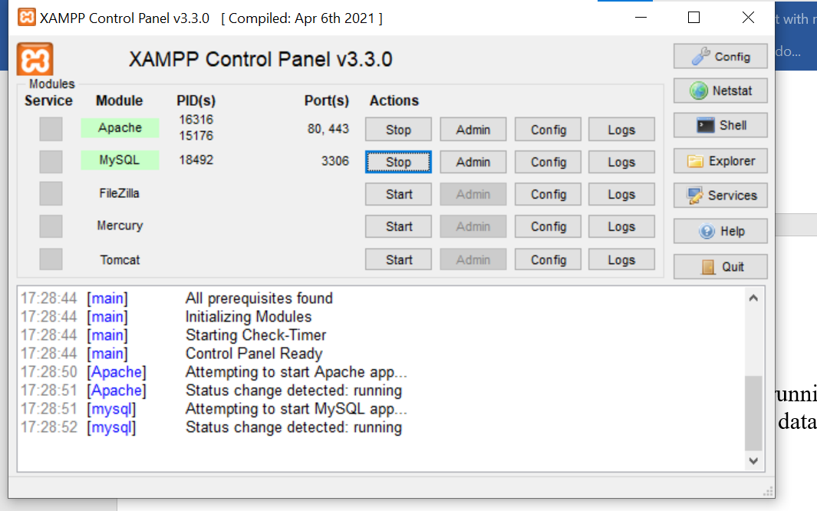

Localhost Test Page
demonstrating successful access to localhost using a browser. This verified that the local server was functioning correctly.

Database Connection Test
connection between PHP and MySQL using mysqli_connect(). It confirmed that the database credentials and server settings were correct.
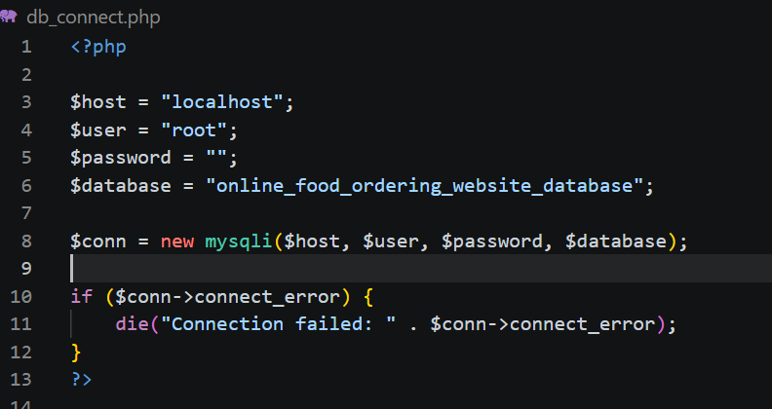
PHP Hello World Test
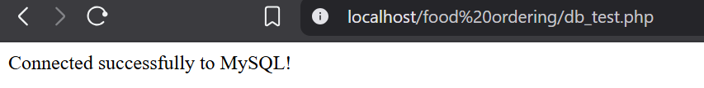

Reflection
During this week, I learned how to install and configure XAMPP for local web development. I used PHP and MySQL to test server and database connections. One challenge I encountered was fixing database connection errors, but I solved them by checking server settings and database credentials.

Week 2: Wireframes and GUI Design

Title
User Interface Planning and System Design

Fig 1: Homepage Wireframe
This screenshot shows the planned structure of the homepage including navigation menus, food categories, and order sections. The design was planned to make navigation easy for users.
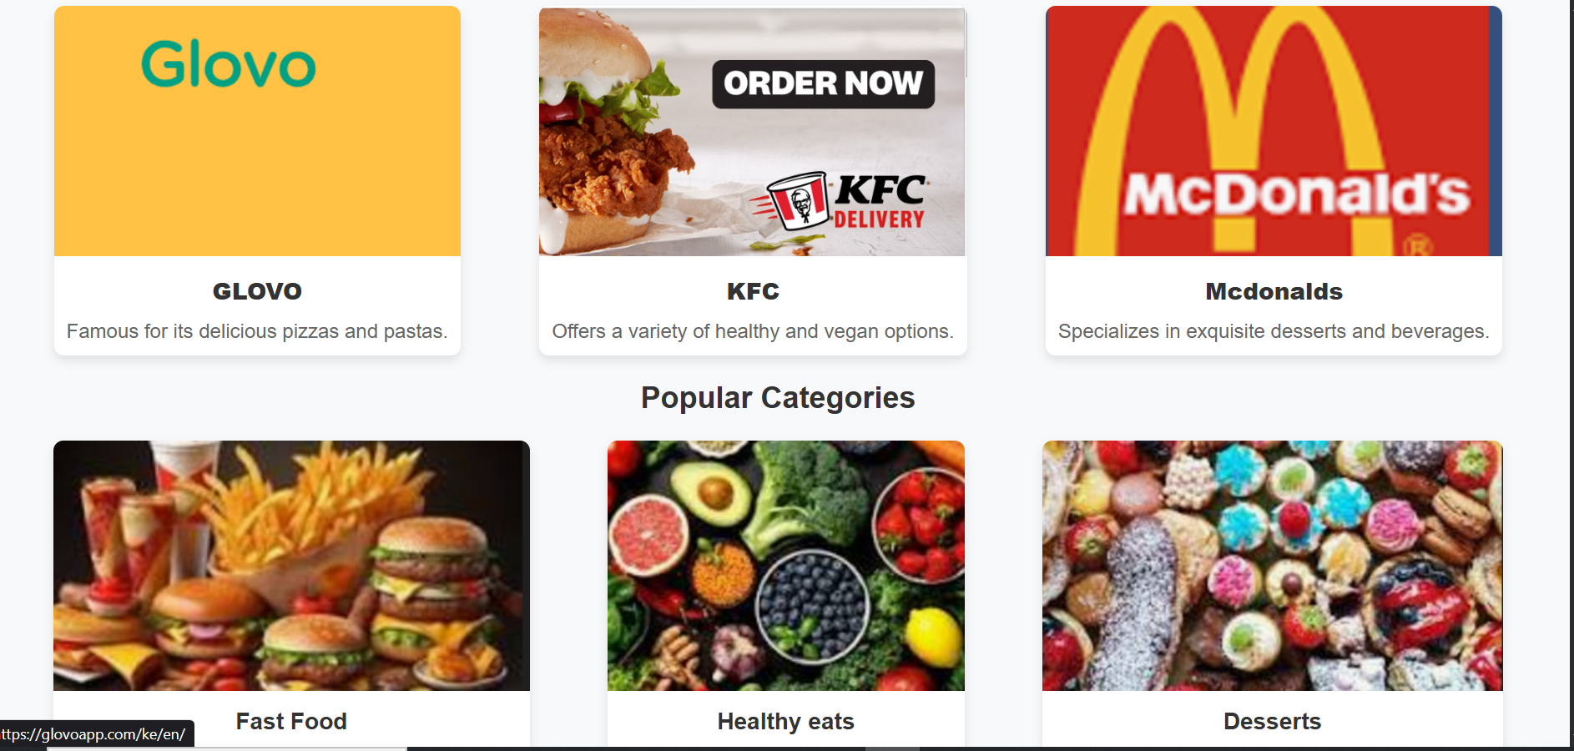

Fig 2: Dashboard Layout
The dashboard layout was designed to organize food items, customer orders, and management sections clearly.
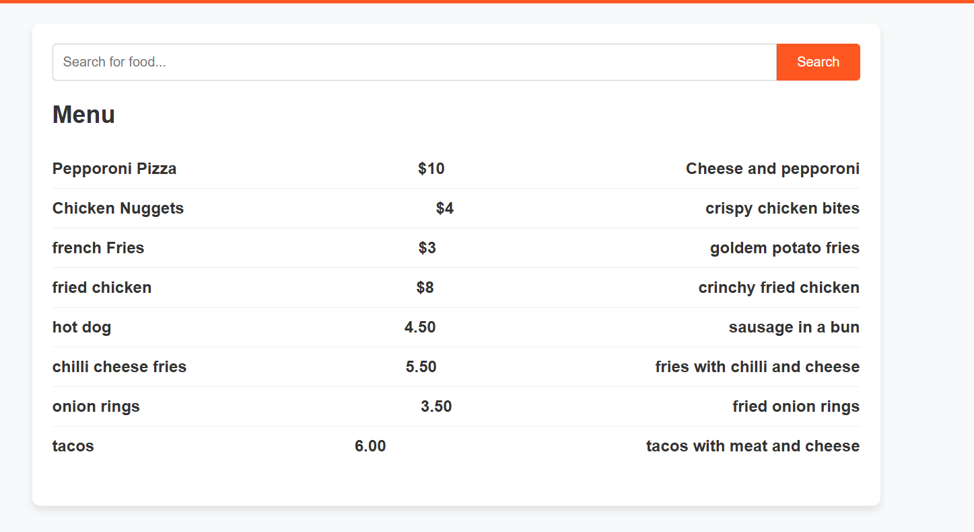
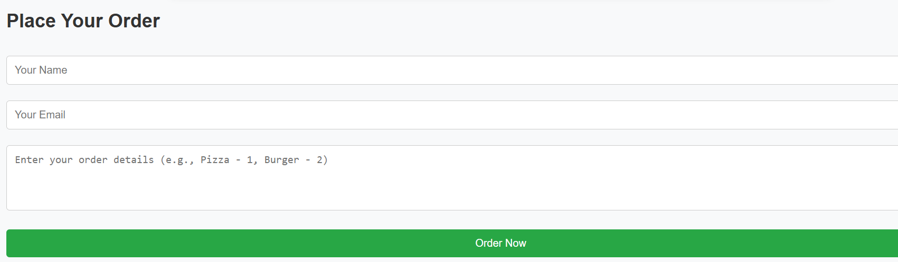

Fig 3:Color Theme and Navigation Structure
The selected color theme improves visibility and user experience. Navigation links were positioned clearly to help users move between pages efficiently.

Student Reflection`
During this stage, I focused on planning the user interface of the online food ordering website. I considered user experience by creating a simple navigation flow and responsive layout. The main challenge was organizing different sections properly, especially for mobile users. The screenshots demonstrate the planning process and GUI structure of the system.

Week 3: JavaScript and PHP Basics

Title
Frontend Interaction and Backend Foundations
Fig 1: JavaScript Form Validation
This screenshot shows JavaScript validation preventing users from submitting empty forms. Validation improves user interaction and reduces invalid submissions.
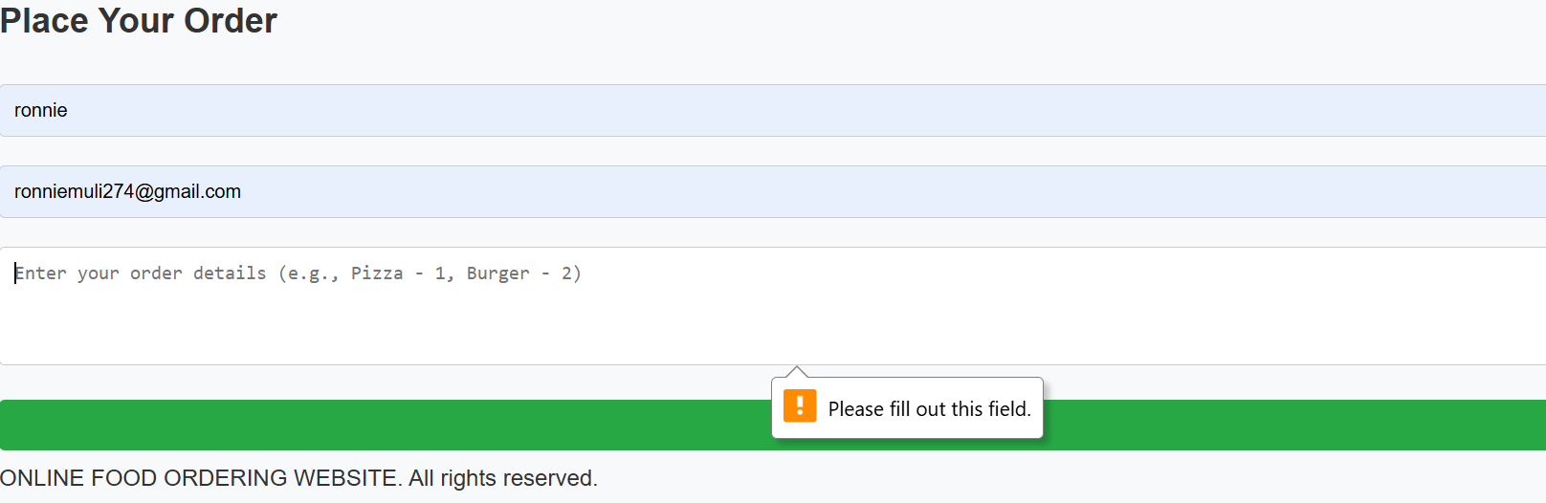
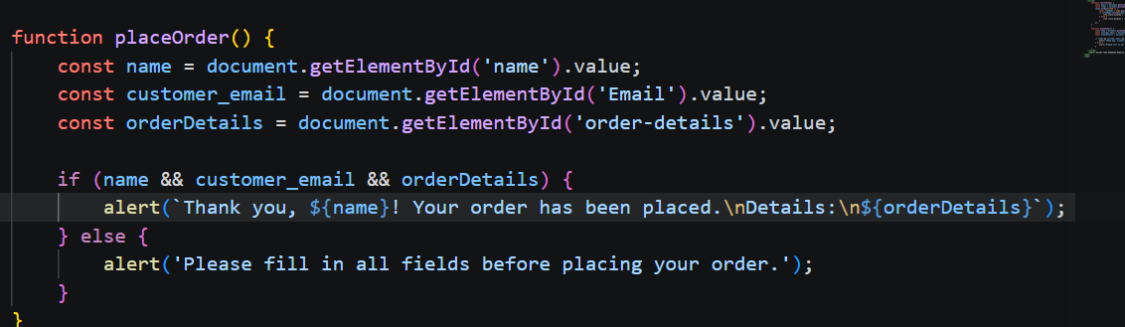

Fig 2: Password Hashing
The password hashing was designed to enhance database password security It hashes passwords ,thus they appear as a combination of characters in the database
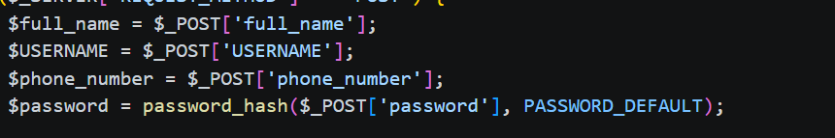

Fig 3: javascript Syntax Practice
This screenshot demonstrates javascript scripting used to process website functionality. Javascript was used to create dynamic pages and handle user requests.
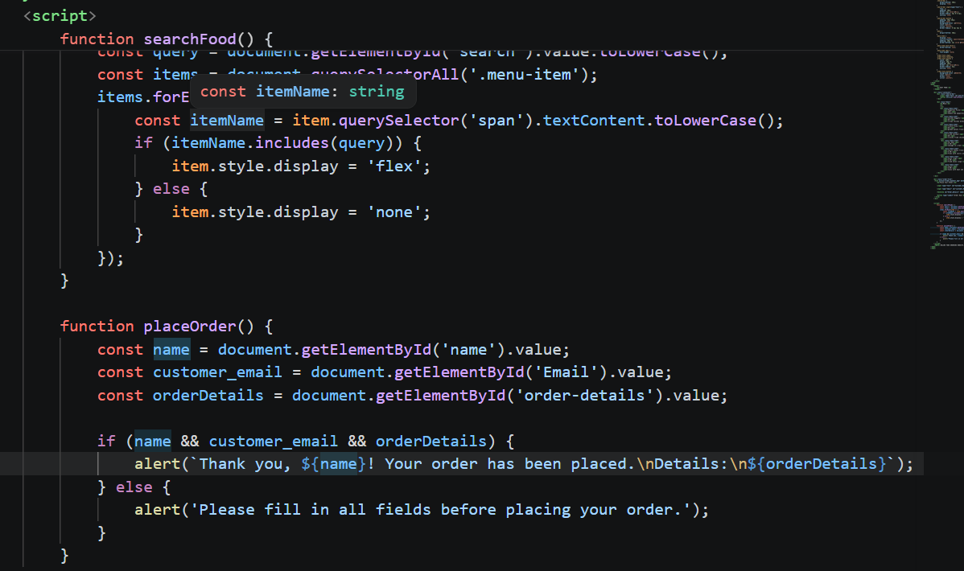

Fig 4: Database Connection Script
This screenshot shows the PHP script used to connect the website to the MySQL database. The connection allows storage and retrieval of customer and food order data.
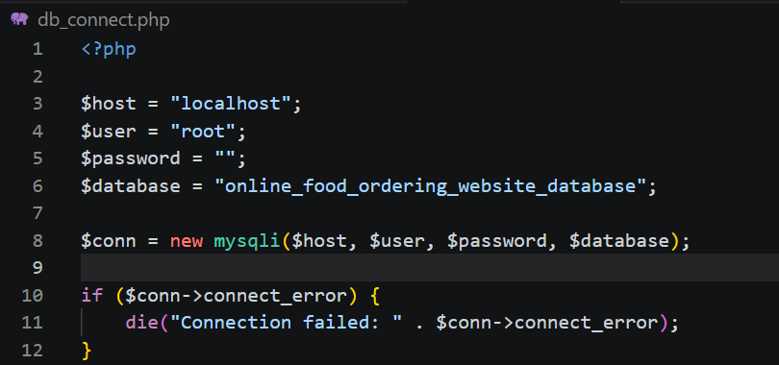

Fig 5: Dynamic User Input Handling
The screenshot demonstrates how user data submitted through forms is processed dynamically using PHP. This allowed interaction between the frontend and backend system.
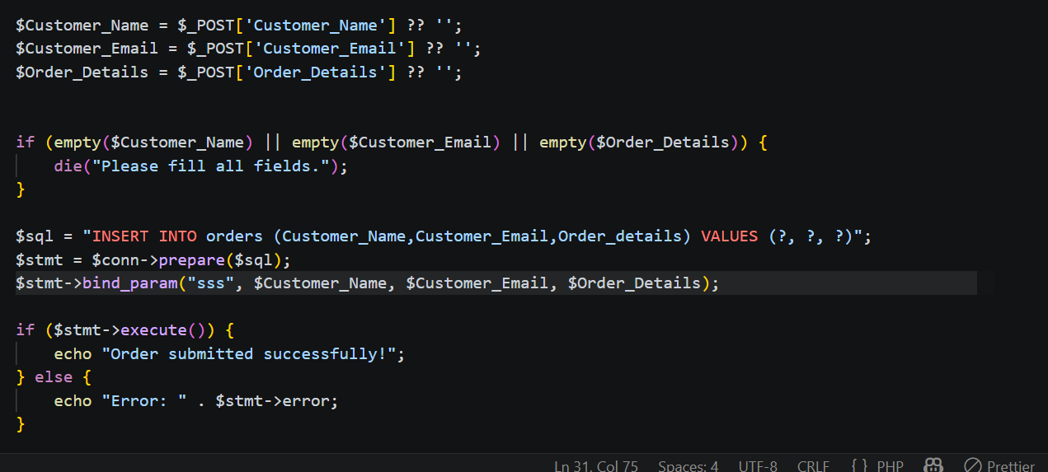

Student Reflection
This week helped me understand how frontend and backend technologies work together. JavaScript improved form interaction while PHP handled data processing and communication with MySQL. I experienced challenges with form validation and database connectivity but solved them through testing and debugging. The screenshots demonstrate backend integration and user interaction flow.

Conclusion
The Online Food Ordering Website project helped me improve my practical skills in web development. I learned how to set up a development environment, design user interfaces, and integrate frontend and backend technologies using PHP and MySQL. The project also improved my problem-solving and debugging skills during system development.

Week 4: Server-Side Components and Backend
Development Foundations

Fig 1: Dynamic main Page
The screenshot shows where the login page is accessed on the main page
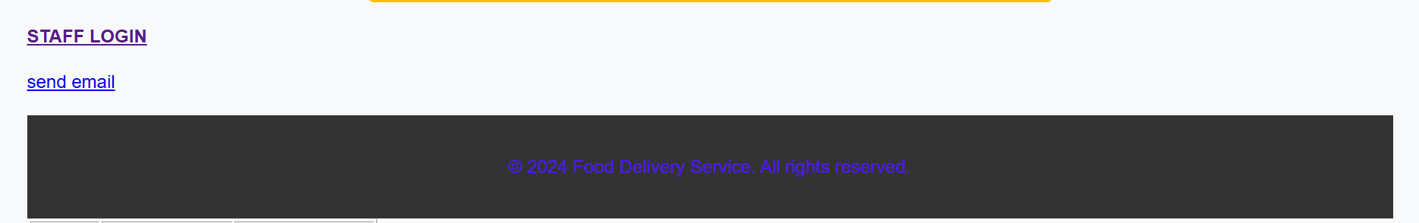

Fig 2: Registration Form
This screenshot shows the registration form used to collect user details. The form sends data to the
server using the POST method.
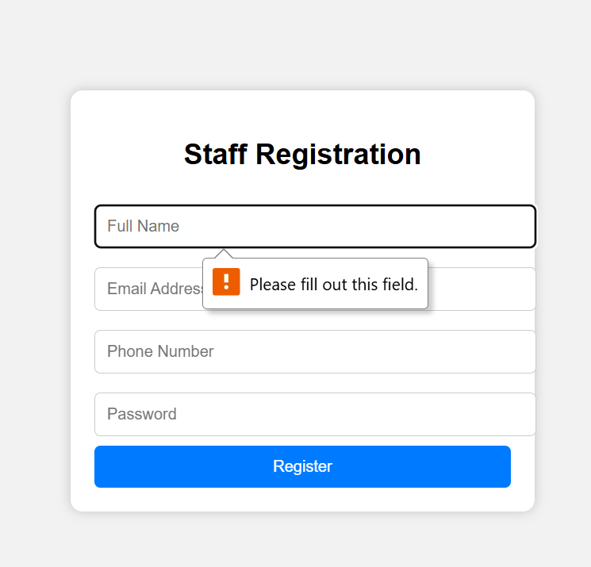

Fig 3: Login Form Validation
This screenshot demonstrates validation of username and password fields before submission.
Validation helps reduce invalid user input.
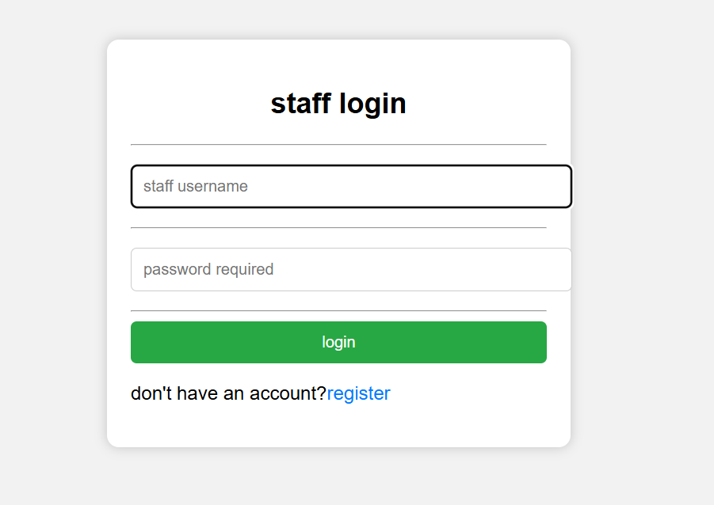

Fig 4: Session-Based dashboard Page
This screenshot shows a logged-in user accessing a protected page using PHP sessions. It
demonstrates basic authentication functionality.
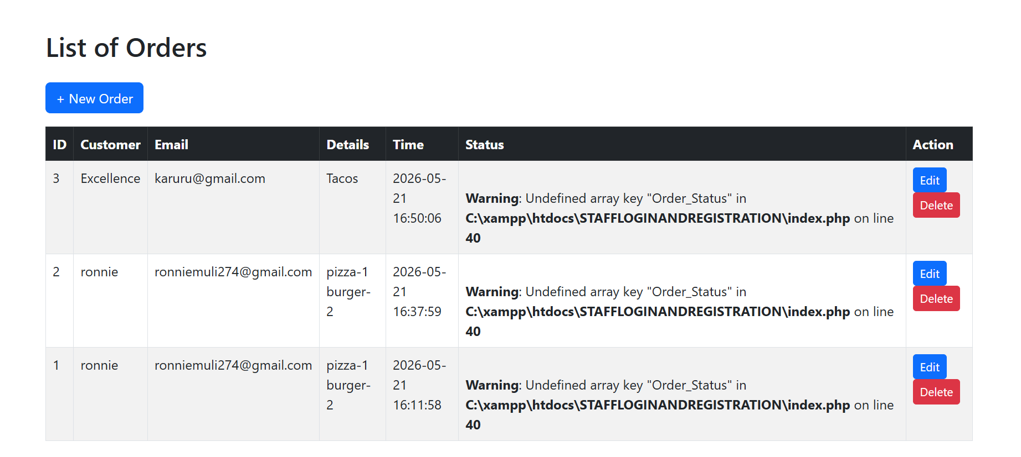

Fig 5: Backend Folder Structure
This screenshot shows the project organization structure including CSS, JavaScript, database,
images, and includes folders.
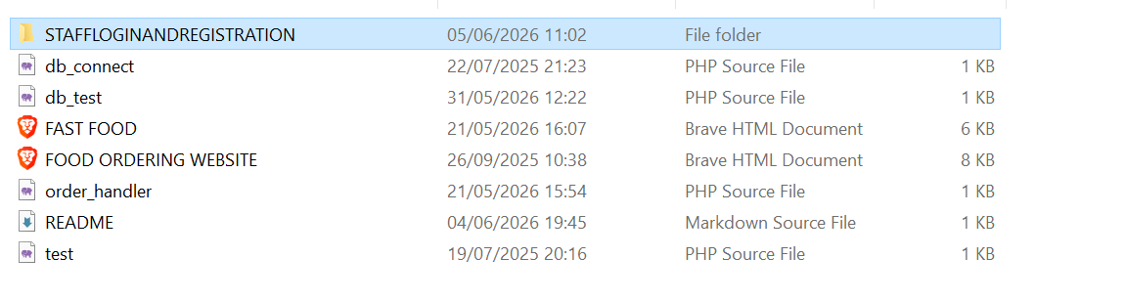

Week 4 Student Reflection
During this week, I learned how backend systems process user requests using PHP. I created
forms, implemented login functionality, and understood how sessions maintain user authentication.
The screenshots demonstrate backend processing, form handling, and project organization.

Week 5: Database Components and CRUD
Operations

Fig 1: Database Creation
This screenshot shows successful creation of the project database in phpMyAdmin. The database
stores application data.
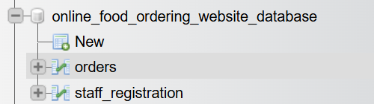

Fig 2: Users Table Creation
This screenshot shows creation of the users table with fields such as Id, fullname,phone number, and password.
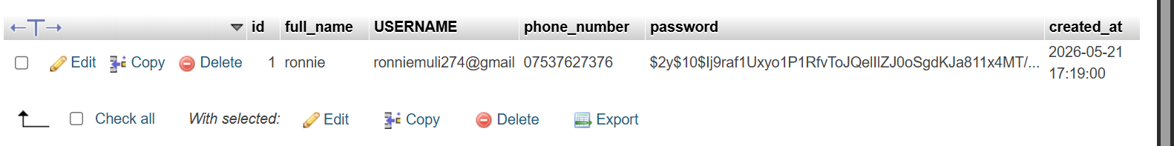

Fig 3: Create Operation
This screenshot demonstrates inserting new user records into the database using SQL queries.
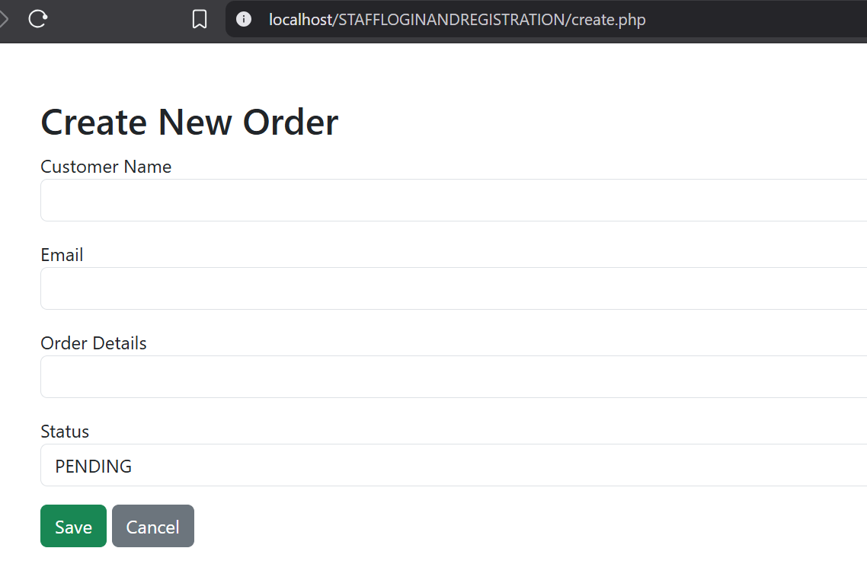

Fig 4: Read Operation
This screenshot shows retrieval and display of records from the database using PHP and MySQL.
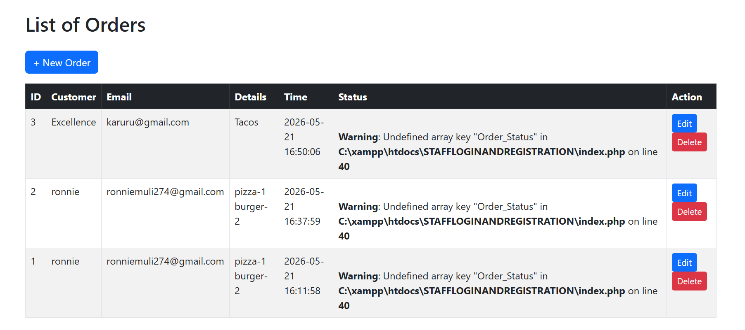

Fig 5: Update and Delete Operations
This screenshot demonstrates editing and deleting records from the database. These operations
complete the CRUD cycle.
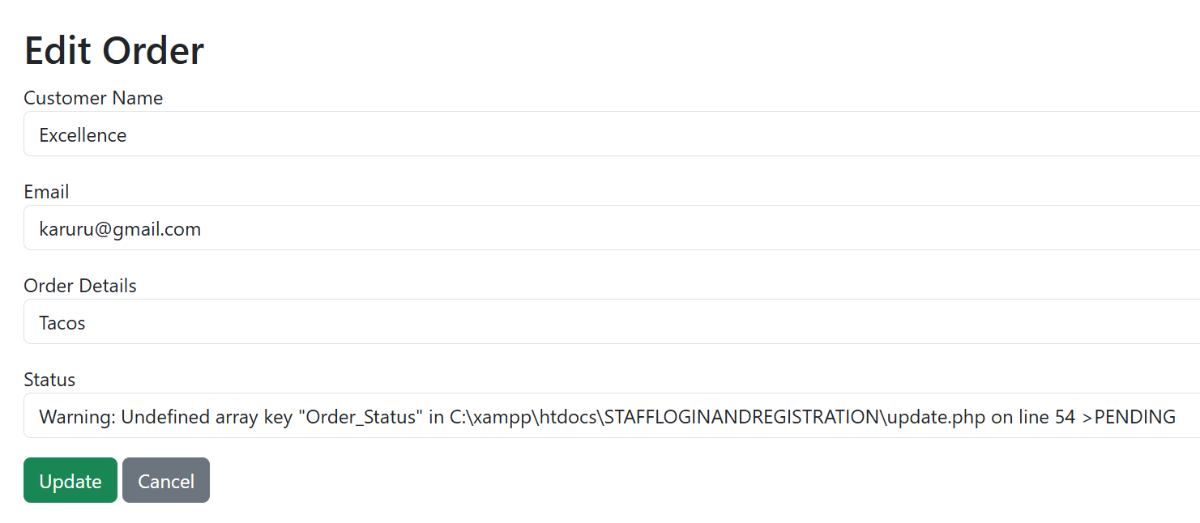
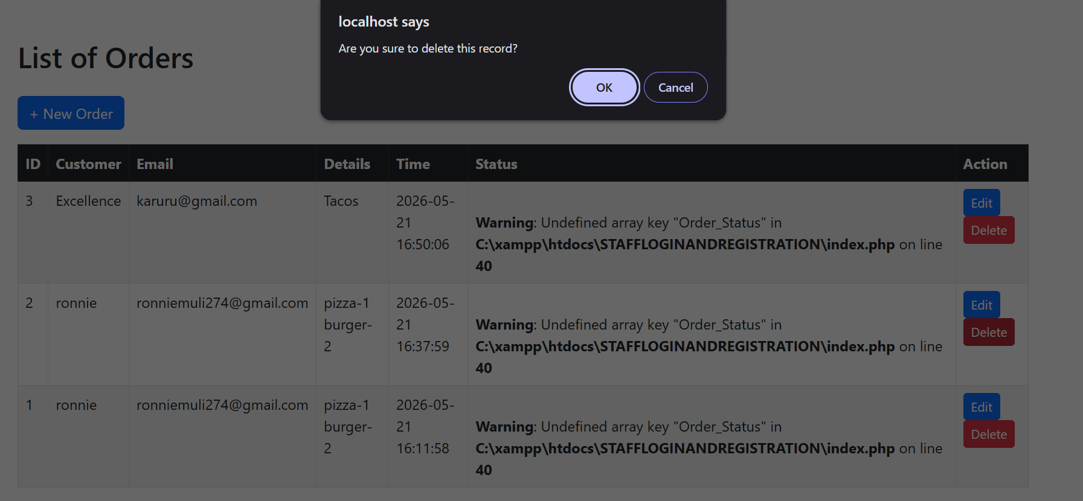

Fig 6: PHP Database Connection
This screenshot shows successful connection between PHP and MySQL using mysqli_connect().

Week 5 Student Reflection
This week focused on database-driven development. I learned how to create databases, create
tables, and perform CRUD operations. I also connected PHP to MySQL and displayed dynamic
data from the database. The screenshots demonstrate successful backend and database
integration.

